|  |
| --- |
| **SOUTHERN CROSS UNIVERSITY** |

**ASSIGNMENT COVER SHEET**

For use with online submission of assignments

Please complete all of the following details and then make this sheet the **first page of each file of your assignment – do not send it as a separate document.**

Your assignments must be submitted as either **Word documents, text documents with .rtf extension or as .pdf documents**. If you wish tosubmit in any other file format please discuss this with your lecturer well before theassignment submission date.

|  |  |
| --- | --- |
| Student Name: | ________Tejinder Singh____________________ |
| Student ID No.: | ____________________24057271________ |
| Unit Name: | **Designing the User Experience** |
| Unit Code: | **PROG2006** |
| Tutor’s name: | __**Golam Sorwar**  __________________________ |
| Assessment No.: | _______________________3_____ |
| Assessment Title: | __The shepherd boy and the wolf __________________________ |
| Due date: | ________04/10/24____________________ |
| Date submitted: | ________________04/10/24____________ |

Declaration:

*I have read and understand the Rules Relating to Awards (*[*Rule 3 Section 18 – Academic Misconduct Including Plagiarism*](http://policies.scu.edu.au/view.current.php?id=00140#s18)*) as contained in the SCU Policy Library. I understand the penalties that apply for plagiarism and agree to be bound by these rules. The work I am submitting electronically is entirely my own work.*

|  |  |
| --- | --- |
| Signed:  (please type your name) | _____Tejinder Singh_______________________ |
| Date: | _________________01/10/2024___________ |

**[The shepherd Boy and the Wolf ]**

**Design Documentation**

By [Tejinder Singh]

Table of Contents

1 Concept Paper 1

1.1 Introduction 1

1.2 Updated sketches and details 1

1.3 Evaluation Form and Feedback 4

1.4 Link to GitHub and itch.io 5

1.5 Module Journals 5

2 Module 1 5

Planning for Assessment 2 8

3 Module 2 9

4 Module 3 11

5 Module 4 13

6 Module 5 15

7 Module 6 17

7.1 Link to Reflective video 18

8 Updated Functional Specifications 18

8.1 Updated User Interface 18

8.2 Updated Storyboards 19

8.3 Final Media List 24

References 24

Appendix 25

Scene 1 25

Scene 2 26

Scene 3 27

27

Scene 4 28

28

# Concept Paper

## Introduction

This is the project which is based on the assessment 2 storyboard of the shepherd boy and the wolf the motive of choosing this concept is the inspiring the coming future generation of between 6 to 15 year old for having the reading book with interactive content of animations, visuals, vibrant colour and this is the last assignment for this project which includes the unity for making the storyboard in the practical form and the feedback from the previous work as well as some updates which are made in the storyboard scenes according to the unity without changing the actual moral of the story.

## Updated sketches and details

Here are some changes which are made for the last project which covers some part of the storyboard such as the background layout, interactive objects and improving the animations with some visual effects, sounds and more vibrant coloring backgrounds which will be added for better interaction and the button is changed as well for navigating the other scenes.

Here is the updated sketch for the last project*.*

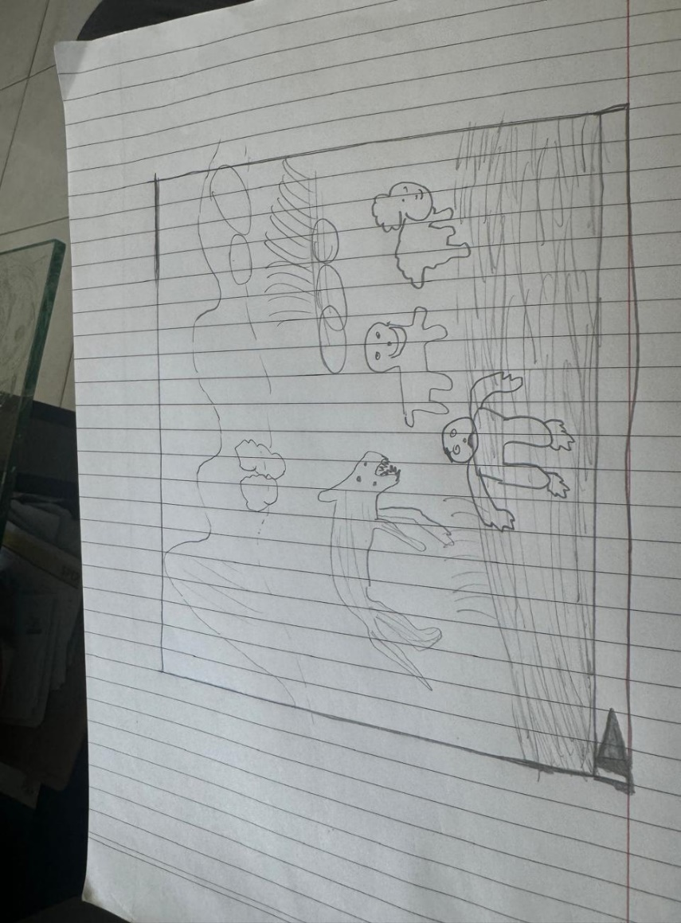

## Evaluation Form and Feedback

Here is the feedback from the teacher and the student for the class for the unity project.

In case of the teacher feedback the simple navigation button for the children interaction as well as improving the interactive elements and the navigation should be working the animations require some extra efforts. Apart from this, the feedback from the peer group was the almost same for the improvement in the unity as well as need to work properly on the script so the navigation should be working properly and the background layout, the visual effects and the objects which are taken from the canvas and the background and the scenario inside it is really amazing which gives more natural vibe.

## Link to GitHub and itch.io

*Place your GitHub (or OneDrive or Dropbox for example) and/or itch.io links in here if you decide to prototype your designs beyond the documentation. Make sure your GitHub project is public as often the links will not work if the project is set to private.*

GitHub: https://_________________

Itch.io: https://_________________

## Module Journals

# Module 1

**Now that you have a better understanding of what constitutes UX design, explain in your own words the difference between UX and UI.**  
UI best practise: The UI best practise assist to know about the visual design as well as the interactive elements which are used in the project or website in this Unit the project is based on the unity in the assessment 3 with 2D interface so both of the interactive element and the visual design are intuitive and easy to use. the best practise cover the layout consistency , simple navigation, effective colours in the product and some other depth concept while working on these types of the project .Moreover, the UI mostly focus on the engagement of the interface with the user and appearance of the product in order to elaborate this , if the user visit on the website the user will find out that the navigation button , search and other option in the website are on the exact place where they are suppose to be Norman, et al., 2013) . Apart from this, the UX(User Experience) is the know for the overall experience of the user on the website or product as well as it could be anything so when the user interact with them then they can find out some emotions ,navigation, engagement of the user with product or how they fell about it all of this refer to the user experience Petrie and Bevan (2009)Moreover, the User Interface is referring to the overall layout and visual appearance of the visual design it could be for any product a person is working , it use to make sure that all the element of the website such as menu, search button icons , header and footer are well positioned for interaction.

**Research some applications and websites that may be similar to the theme of your application. Using these for inspiration, for each of the following, briefly describe how you might consider these in your storybook application design:&nbsp;  
  
  
layout  
navigation  
conventions  
graphics  
text and  
colour  
  
  
Make sure to include the sites you visited in your answer. Next week we will be looking at creating mood boards from the sites we visit to gain inspiration.**  
 Here is the website which is used for the assessment 1 and all of the requirement for this questions are covered in this https://www.sbs.com.au/theboat/   
So in the case of the storybook application design on which i am working this is the website which is used as the inspiration for the assessment 2 in the case of the storybook application design the layout is focused on the visual narratives with simple design with free of clutters so the focus will be on the story along with this, the websites such as the https://dribbble.com/ and the aforementioned website is the best example where the animations and the pictures are in the best used and primarily focus on the best interaction.  
Here is the website which is used for the assessment 1 and all of the requirement for this questions are covered in this [https://www.sbs.com.au/theboat/](https://www.sbs.com.au/theboat/%20)   
So in the case of the storybook application design on which I am working this is the website which is used as the inspiration for the assessment 2 in the case of the storybook application design the layout is focused on the visual narratives with simple design with free of clutters so the focus will be on the story along with this, the websites such as the https://dribbble.com/ and the aforementioned website is the best example where the animations and the pictures are in the best used and primarily focus on the best interaction. Secondly, the navigation is easy to use in the Boat story where the user only need to scroll down for reading the content and the navigation for the every chapter is on the right hand side. in addition to this, the conventions cover the part of the swiping the gestures, easily find out the icons, and buttons so the overall meaning of this is the user can find out the way of navigating the story which is easy on the boat in first gaze Petrie and Bevan (2009). Graphics are the curcial for this unit project because in order to make engagement of the young ones with the content of the story the graphics plays a crucial role so the project took the inspiration from the boat and the https://storybird.com/ website for this assessment. Lastly, the text and the colour are the important ones as well the text is used in the arial and the colour is used for making the emotions with vibrant colour Petrie and Bevan (2009).

**Choose one of the websites from the previous activity and briefly describe your user experience using the website. &nbsp; Remember, there are no wrong answers here. Your UX can be bad or good or even neutral. For example; you may talk about color, text, layout**  
The Website which is chosen for the assessment 1 is the Boat and overall experience with visual appearance and the content with colour which is completely aligning with the overall story and the images , animations as well are allign perfectly which gives the rating of this website 4.5 out of 5 but there are some issues with the features which are placed in the left bottom side for the user which is not visible properly while some scroll down for reading the content only the people with good vision can see properly otherwise the old aged people can not seen or find it easily..

# Planning for Assessment 2

**:**

* The planning for the assessment two is based on the a lot of concepts such as the pre planning and the last/ final draft of the project, before going further the story is based on the shepherd boy and the wolf the purpose of the story is to engage youngsters with reading the books and it is demonstrated with the handcrafting on the note book in the 2D interface and in the storyboard there will around six pages to demonstrate the story then the elements such as navigation bar , the sound and other elements will be used and in the final once everthing is chosen and the colour style as well.

# Module 2

**In your own words, write down your understanding of Design thinking. How do you think you might design your prototype for your Assessment 2 project using Design thinking? &nbsp;You only need to write a small paragraph and you don’t need a lot of detail unless you want to. Just be mindful that you have only 1000 characters to work with (100 to 200 words).**  
Design thinking is the user centred approach which focus on the key concepts such as the customer requirement and the illustrating the problem, generating thoughts, testing of the project this method is use for the working on the idea and then work on the feedback for good user experience.

**In your own words, write down how you might identify personas for your design project. Identify one persona and create a quick User story for that persona. Be mindful that you have only 1000 characters to work with (100 to 200 words).**  
Identifying Personas: In order to cover this part, the personas will be based on the user information such as the requirement , the goal and the issues will be encounter by the persona. the persona is my 8 year old nephew who is fascinated about going through interactive stories which cover all of the things such as animations ,visual designing and other details as it is mentioned in above and previous journal notes. Long, F. (2009, May). The goals are only for navigating the storybook easily with colourful visuals and simple interaction lastly, the user is only fond of having good user experience should be realistic and engaging because when the person navigate to other page the the user can enjoy the story in fun way Long, F. (2009, May)..

**Write down three advantages of prototyping.&nbsp;Write down three of the potential problems that could be encountered when prototyping a product:&nbsp;How can these problems be overcome? Be mindful that you have only 1000 characters to work with (100 to 200 words).**  
 Advantages and Problems of Prototyping:  
In case of advantages the first advantage is that the person who is working on this project can identify the flow of the design which is going to display before showing the final draft of the assessment , validation of the idea from the user feedback by repressing the prototype, assist to work before as time saving way and give clear vision without being unclear about the idea to someone Camburn et al. (2017).  
  
Problems:  
Even though, it is mentioned in the advantages that the pre released draft of this project could be helpful for time saving but in some cases it can be challenging according to the requirement of topic so in order to cover them the user need to focus on the core features of the work before collecting all or focus on the every requirement. Secondly, the prototype can not be 100% technically achievable so to analysis of this project needs to work with developer so they have some desirable outcomes in future Camburn et al. (2017). Lastly, the user need to focus on the layout and the design of the content rather then working on the completion of the content in the storyboard , so the analysis has the dire need of making the proper storyboard design rather then explaining the full story Camburn et al. (2017).

**Write down ideas you may have for your theme for the key elements of your application:  
  
  
colours  
sounds  
fonts  
background  
icons  
theme  
other notes  
  
  
Be mindful that you have only 3000 characters to work with (430 to 750 words).**  
Colour: the use of the colour id different according to the content so in this the use of the dark black , brown and red with engaging story for the young ones is suitable option. Sound the sound will be the page turning according to the 2D story. The font is used as the Arial in the assessment 2 as well as for 3 in Unity. Icons: are on the top right of the interface which will helps play the sound and the for stopping the scene. Lastly, the theme is based on the Redemption and trust type with meaning idea for user with short description.

# Module 3

**This week, you have learned about accessibility. In your own words, explain how you have implimented a user-centred design approach to your project.**  
User-Centred Design Approach  
This approach is mainly focus on the accessibility and the efficiency of the design, the focus of this is based on the many concepts first of all, the interface should response on the many devices with different age group and ability. this covers the highly contrast background colour and text for reading, intuitive navigation, suitable font as well as the people with disability can also find out and interact with the layout with the eminent principles of navigating through keyboard and use alt text for finding out the images. Lastly, as the goal of the other website or product maker the goal for this is same that the user can have high quality of user experience without having any obstacle while they go through of it .

**Copy and paste the link to your survey here!**  
There is no link for the survey which is made for this project but there are question which were asked in the survey.  
  
1. How will you rate the overall experience with our website.  
1. Good  
2. Not Bad  
3. Highly Engaging  
4. Average  
2.Which features did you find the most useful in the product.  
1. Animation  
2.Design   
3. layout  
4. other  
3. What suggestion you would prefer to give for the improvement.  
Answer:

**Create 4 questions you want other testers to answer to rate/test your project. These could be as simple as:  
  
  
Do you belive the app considers white space?  
The colours in the app were designed to mimic a "cool" or "cold" feeling. Did the colours on the app enhance your expeience by making you feel cold or cool?  
Were you able to navigate to the other pages easily?  
Was it easy to work out how to navigate through the app?  
Did you understand the purpose of the icons the app uses for social meida?  
  
  
These are just to name a few - You may use one or two of these, but make sure to come up with some of your own. You should consider things like graphics, colour, design patterns, layouts, navigation, icons and anything UX related.**  
1. Did you encounter any graphics, colour, design patterns, layouts, navigation, icons and anything UX related problem while checking the website.  
2. what are the some suggestions you can provide us to improve the user experience for the future Schrepp (2015).  
3.Were all the elements in the project were working or any issue you had while reading such as high contrast background colouring hard to read or images were not displaying in the pages Schrepp (2015).  
4. Were the animations and the pictures were giving real life experience Schrepp (2015).

# Module 4

**This week we have learned about human psychology and how it can impact on the design choices we make. List the two main types of memory and then in your own words, how does your design take into consideration the following aspects of human:  
  
  
memory  
cognition and  
perception?  
  
  
Finally, in your own words, explain how an app may cause "cognitive friction" in their users?**  
Short term ( working) memory is the short time period of storage of the information where the short amount of the data can be stored in order to accomplish the task for short term. In contrast, the long term period store the huge amount of data for a long time of period which assist the user to recall everthing and to learn skills (Sweller, 1994; Sweller, Paas, & Van Merrienboer, 1998).  
Human Memory: In order to recalling the memory of the user this project assist in the way in which the important function are visible and accessible in every time. so to reduce the mental strain on the storyboard they do not need to keep any feature in their mind while they are navigating the pages, the navigation is in every story board with inoperative family icons and layouts so when go proceed further they do not look any where to find out the navigation button  (Sweller, 1994; Sweller, Paas, & Van Merrienboer, 1998).  
Cognition: Having clear and unclutter interface can aid to reduce the cognitive load as well as managing the complex task into the smaller and information in this engaging content is easy to digest by the user without being bored. Navigation and other feature are easy to use without making extra effort to find out the this by the user.  
Perception: The design is quite obvious for this project which will lead the attention of the user with contrast colour, visual order and the information is design as the attrack toward someone in first gaze and the information is grouped logically , one last important thing which is consider for this is the colour blindness in the design which aid every type of the user for accessibility.

**This week we also learned about designing for different platforms. In your own words, explain how your design might be impacted by the screen sizes of different devices. How might you overcome these challenges or how did you overcome these challenges?**  
Cognitive friction: This is usually arise when there is any fresh website or product is designed so normally the navigation, app design also the interaction make it harder for user to use the platform for their task. in order to elaborate this, if the user find out the button and the navigation in the menu so not working properly or giving the message that the site cannot be reached they this thing will lead towards the frustration level of the user and they may give their bad review on it which is not quite good for this product in the market (Interaction Design Foundation, 2010)

.  
  
Different screen size matters a lot in this case such as the mobile, laptop ,computer, tablet they have their own different interface of representing the information so in case of the mobile there will be surety that the all information of the product will be available but it will be available in limit amount but the larger screen such as the laptop has got ability to display all the information in full page , so in order to tackle with this ,the design is responsive and it can fit automatically in every screen size also they button and text will be scaling according to the design as well as after making sure that the design and visual will be remaining same without any new issue then the option for the website in the mobile phone which is the desktop site is accessible so that the text and the content as well as other element size could be display as small but it has the ability to give the exact interface which is available in the big screen (Interaction Design Foundation, 2010)

.

# Module 5

**Thinking about what you have learned this week, describe how you might update your design to try and improve user UX based on interface features like navigation, look and environment. Has your design changed since learning about the different types of feedback and feedback channels? Either way, explain why or why not your design has changed.**  
There are numerous ways which can be used to improve the user experience of the current design for this unit. Which are highly mentioned the navigation, visual look or the environment can be considered the background. the navigation covers the simple menu structure in which there will use of grouping similar features because it will reduce the number of click and only use for the important pages with some highly interactive elements which will cover with hover effects and animations on the buttons. Moreover, the look matters a lot so in this the consistency is crucial and it use to make sure design is consist across the platform and this cover the colour scheme, typography, button style as well as the animation. Environment should be welcoming and immersive so to improve this there should be use of spaces, background themes are the concepts which are needs to be covered in the environment case so the environment has changed as well because I use the canvas which is useful and best designing tool which i have found so creativity and making the background for this task. Moreover, the design has been changed for the final project which is assessment 3 because the background and the animations, sound , colours effects and some other visual will change however, the content and the base of the story will be same as the assessment 2 so here are some changes which are possible such as the visual feedback which is accessible to every user such as changing the colour or scene of the storyboard on click and the progress indicator which aid to user if there is the case of the loading huge data then the some type of animations will be displayed to inform them moreover the user centred feedback and the multiple feedback channels so both of these ways can help to every corner of feedback from the user to improve their product.

# Module 6

**Investigate a single AR or VR technology prior to the year 2000. In your own words, research and explain how this AR or VR technology has made an impact on current technologies.**  
Virtual system was one of the recognizable innovation which was ever seen before 2000 in the virtual reality technology and it was released in the early 1990, apart from this, for the immersive gaming experience from the virtuality in cutting edge there are two types of technologies are used which are head mounted display and the motion tracking technology (Sandy B, n.d.).  
The impact on the current technology is widely seen such as in industry field because the rise of the virtuality is used in the entertainment industry so the VR is used as the pathway for the storytelling therefore the VR is used so often in the field of the theme park, museum and live events. On the other hand, the AR the argument reality which works on establishing the framework from early virtual world so that the production of the product as the google glass and the mobile apps. This technology is continuously growing in the field of the navigation, advertising and retails and other for making the better user experience (G2, 2023).

**Copy your script you will use for you presentation in here!**  
The script for the presentation is written in the PowerPoint slides as well as the other evidence such as pictures and everthing is available there.

## Link to Reflective video

Here is the link for the PowerPoint presentation of the Assessment 3 and the video is made with the use of the zoom and the link is accessible to those only who are joined with the Southern Cross University.

# [video1009874683.mp4](https://scuonline-my.sharepoint.com/:v:/g/personal/t_singh_34_student_scu_edu_au/ETJXKE5U3JNGhnfz_G9XDbMBc8KYDVG723P1zTqKqZpYPQ?e=Jad8jS)

# Updated Functional Specifications

## Updated User Interface

The user interface has been changed because of using the same story in the from assessment 2 to assessment 3 simplified icons for the navigation because it will lead towards the compliably of writing the script and the vibrant colors for engaging content for the user.

## Updated Storyboards

**Title**: Home Page **Frame ID**: *Home*

**Scenes: The scenes are available in the appendix section.**

**Dimensions:** 1920x1080 pixels

**Media Used: background colours, images, are taken from the canvas for providing the better user experience and the animations are made for unity** (mixkit.co,2024) (Freesound, 2012)**.**

**.**

**Buttons: The play button is used only for the proceeding further and the animations as well as music will start to play.**

**Background**: Colourful background with sheep, wolf, trees, water, the boy, grass, blue sky.

**Content: The background of the village with blue sky with villagers and the boy with their sheep in the first scene. There are only four scene in the final project so the content is change and it is just minimized after considering the complexity it can bring while working**(www.read.gov, n.d.)**.**

**Animations:**

Birds are moving in the first scene.

**User Interactions Required:**

The user only needs to press the play button which is 🡪like this.

**User Feedback:**

The layout of the new storyboard is simple and attractive which is easy to use for the user.

**Navigation / Links:** Start button will use to take further scene in the storyboard(Tidwell, 2010)..

**Scene 2:**

**Description:** The boy though about to do something interesting and he start to say wolf wolf and gather the villager when they arrive they saw there was no one and the boy starts to laugh and they left him with his sheep alone after feeling being fooled(www.read.gov, n.d.).

**Navigation and user interaction:** The navigation system and user interaction along with button is same as the scene 1(Tidwell, 2010)..

**Media Usage**: The media in this is the sound which is the laughing and running when the villager run and arrive.

**Dimensions:** 1920x1080 pixels

**Background:** The background is the almost same as the part one but just some extra cloud and tress.

**Scene 3:**

**Content:** After making fool to the villagers this time the wolf actually visit to the boy and kill all the sheep and he asked for the help but this time the villager did not approach himand the boy continue to cry(www.read.gov, n.d.).

**Navigation and user interaction:** The navigation system and user interaction along with button is same as the scene 1(Tidwell, 2010).

**Background:** This time the background is almost same, but two scene is divided into two faces in one the boy is crying and the other is for people who ignore the boy screaming and continue to work.

**Dimensions:** 1920x1080 pixels

**Animation:** The wolf attack and the sheep running audio with animation when the wolf attacks the scene depict the attack animation on sheep.

**Scene 4:**

**Content:** The Last scene of the story tells about the moral of to the young ones that the “*Liars are not believed even when they speak the truth”* (www.read.gov, n.d.)*.*

**Animations**: There will be the animation of the text which is the moral of the story in the last scene as well as after this there will be the scene of the credit to provide the information.

**Dimensions:** 1920x1080 pixels

**Navigation and user interaction:** The navigation system and user interaction along with button is same as the scene 1(Tidwell, 2010)..

**Background**: The background is pretty much same as the scene 3 there is nothing to do in this.

**Media Usage:** Only the audio of cry and the animation of displaying the moral.

## Final Media List

|  |  |
| --- | --- |
| Image name or description | Resource address/URL |
| Wolf Attack | <https://mixkit.co/free-sound-effects/wolf/> |
| Boy Cry | <https://mixkit.co/free-stock-music/discover/cry/> |
| Peacefull Village Background audio | <https://pixabay.com/sound-effects/search/peaceful-village/> |
|  |  |
| Wolf Picture | <https://www.canva.com/design/DAGShSQMQZc/x1fC17m5CNuFaOROfIJvbg/edit?ui=eyJEIjp7IkoiOnsiQiI6eyJBPyI6IkEifX19fQ>  <https://www.canva.com/design/DAGShdMEJ1E/WEliHHQAcORbgdYZb3i5pA/edit?ui=eyJEIjp7IkoiOnsiQiI6eyJBPyI6IkEifX19fQ> |
| Boy Cry | <https://www.canva.com/design/DAGSheDZUPo/WvEyrZ5ybnkSO9_iFIGyMg/edit?upload.media=upload_521d93be-d70a-4b71-92db-718a6085bd19&set.page.1.elements.local-image.fill.image=upload_521d93be-d70a-4b71-92db-718a6085bd19&set.csrf-token=NTMliKayBdyPW8DLOC0CtCAIkOAVBkVzjjtcH9iG1OaPSGNlRMrJS94mx2YWJdyMfhQiGmpifbxbrWXcLYoJXQVS9nFC2tFOLRRk6fMg1Wd2c4HRpPMOW7HysSqvApFoJRqwObsotOIAouXVj40Ud6J3aSo> |
| Background | <https://www.canva.com/design/DAGShZPuCp4/Qag-gr2SnjMtY_oBI4_XMw/edit?upload.media=upload_226b4db6-e490-4d1a-bb96-207ad50104dc&set.page.1.elements.local-image.fill.image=upload_226b4db6-e490-4d1a-bb96-207ad50104dc&set.csrf-token=gplzuziyVQjjDJaEEzOc7_W-omGnZ-uwBjVYQfZAyrLilfCdJ8pJ6w4YoT-QaEKFFxZam5CrL5wiTDLAcGu2PAqVAnKGI94yhfhGseOF0BON4FTzFvDprUhXX4tOP8uDjNKzgzCwlJUmMtWK3Qt18Qneejo> |
|  |  |

# References

* mixkit.co. (n.d.). *Download Free Wolf Sound Effects | Mixkit*. [online] Available at: <https://mixkit.co/free-sound-effects/wolf/>.
* Petrie, H., & Bevan, N. (2009). The evaluation of accessibility, usability, and user experience. *The universal access handbook*, *1*, 1-16.
* Freesound (2012). *Freesound*. [online] Freesound.org. Available at: <https://freesound.org/>.
* Pixabay (n.d.). *Pixabay*. [online] Pixabay.com. Available at: <https://pixabay.com/>.
* Long, F. (2009, May). Real or imaginary: The effectiveness of using personas in product design. In *Proceedings of the Irish Ergonomics Society annual conference* (Vol. 14, pp. 1-10).
* Camburn, B., Viswanathan, V., Linsey, J., Anderson, D., Jensen, D., Crawford, R., ... & Wood, K. (2017). Design prototyping methods: state of the art in strategies, techniques, and guidelines. *Design Science*, *3*, e13.
* Tidwell, J., 2010. *Designing interfaces: Patterns for effective interaction design*. " O'Reilly Media, Inc.".
* www.read.gov. (n.d.). *Library of Congress Aesop Fables*. [online] Available at: <https://www.read.gov/aesop/043.html>.
* Akhmedov, N., 2023. *Designing and prototyping a learning and testing platform for user experience (UX) and user interface (UI) designers with the aim of improving knowledge and establishing a standard evaluation benchmark for UX/UI design skills and competencies* (Doctoral dissertation, Technische Hochschule Ingolstadt).
* Johnson, J., 2020. *Designing with the mind in mind: simple guide to understanding user interface design guidelines*. Morgan Kaufmann.
* Dreier, O., 2016. Doing things with things: The design and use of everyday objects. Routledge.
* *The Design of Everyday Things by Don Norman | Basic Books*. (n.d.). <https://www.basicbooks.com/titles/don-norman/the-design-of-everyday-things/9780465050659/>
* Tidwell, J. (2010). *Designing interfaces: Patterns for effective interaction design*. " O'Reilly Media, Inc.".
* Akhmedov, N., 2023. *Designing and prototyping a learning and testing platform for user experience (UX) and user interface (UI) designers with the aim of improving knowledge and establishing a standard evaluation benchmark for UX/UI design skills and competencies* (Doctoral dissertation, Technische Hochschule Ingolstadt).
* Sweller, J., Van Merrienboer, J. J., & Paas, F. G. (1998). Cognitive architecture and instructional design. *Educational psychology review*, *10*, 251-296.
* Interaction Design Foundation (2010). *UX Design Courses & Global UX Community*. [online] The Interaction Design Foundation. Available at: <https://www.interaction-design.org/>.
* Sandy B (n.d.). *History of Virtual Reality (VR) – VR.org*. [online] Available at: <https://www.vr.org/about-us/history-of-vr/>.
* G2. (2023). *A Brief History of Augmented Reality (+ Future Trends & Impact)*. [online] Available at: https://www.g2.com/articles/history-of-augmented-reality.

# Appendix

Scene 1

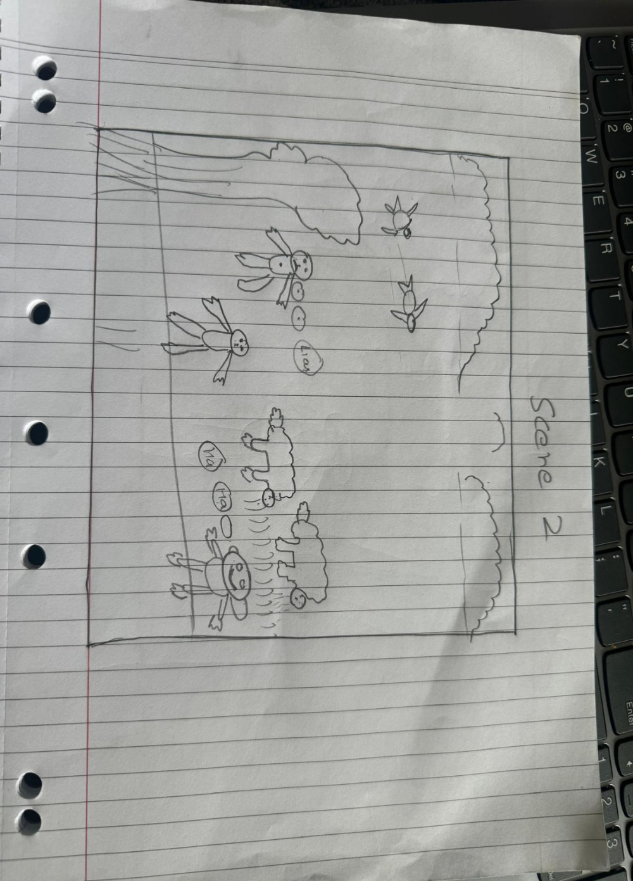Scene 2

Scene 3

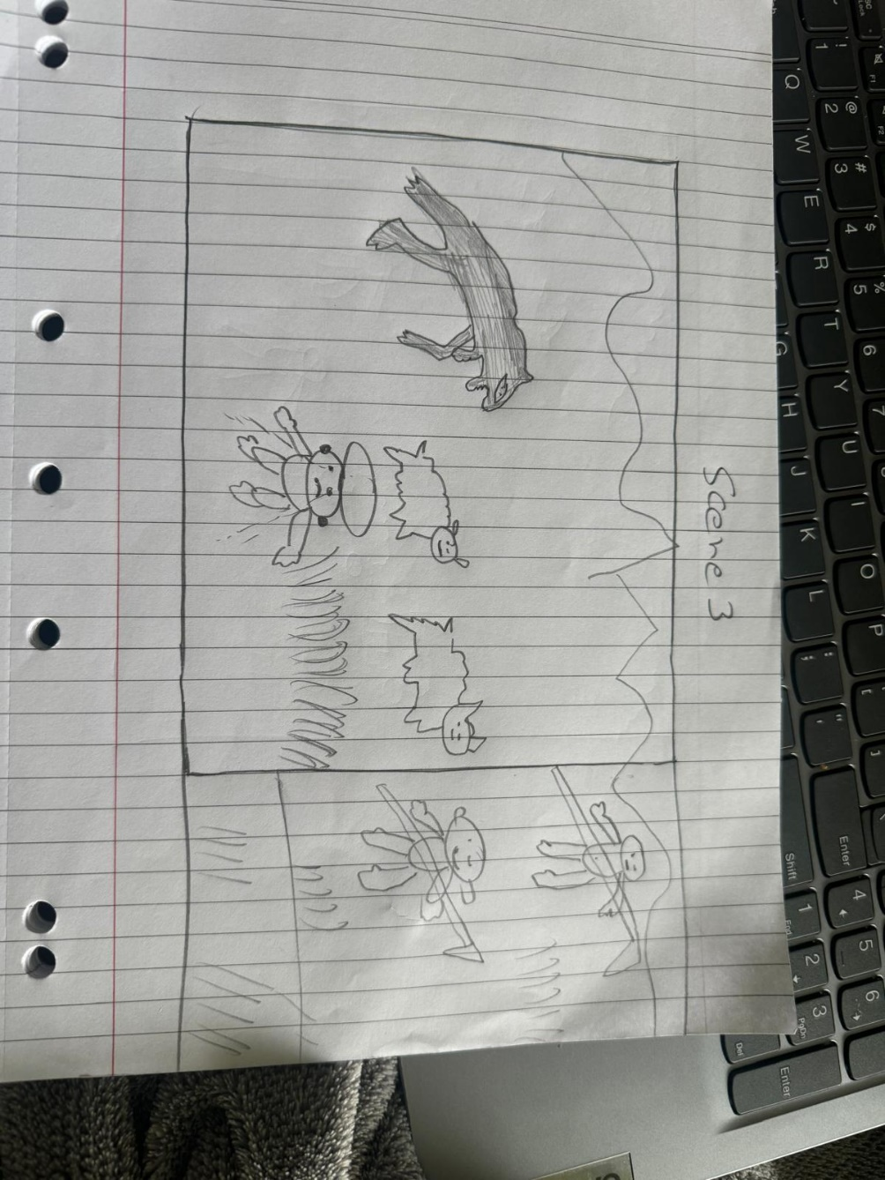

Scene 4

